tlog2chart Phase 3 Basic Analysis Report
File: 06-Chronos 2.0-37 19600052 tlog.txt
Unit Type: Chronos 2.0
Unit FW Ver: 56
Unit FPGA Ver: 109
Unit SN: 19600052
Tool: tlog2chart_P3 v1.3.6
Generated: 2026-03-10 20:48:48

Analysis Settings
- Active threshold: Pfwd > 3.00 W
- Step4 tolerance: ±2.0% | settle time: 6.0 ms (Tykon only)
- Step5 reflect rule: Pref > 1.00% of Pfwd | mask first 3.0 ms
- Pulse mode range: Freq 0.01–50.00 kHz, Duty 10.0–90.0%

Step 1 — Full Scale Overview
Full plot of Pfwd/Pref/Pdel across the entire tlog.
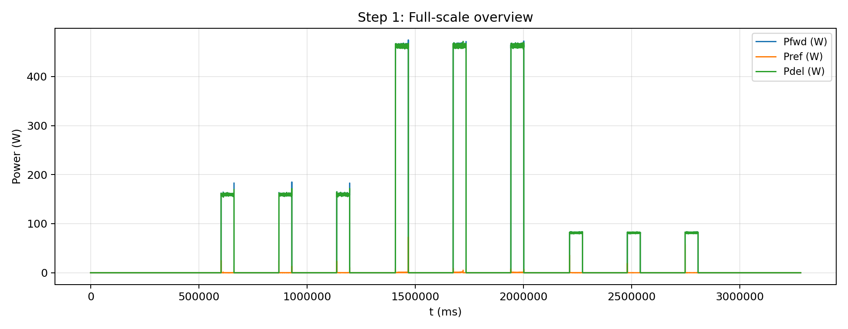
Figure 1. Full-scale power overview.

Step 2 — Zoom In to last RF event with 100x smaller time span than Step 1, improving resolution around the last power event.
This plot zooms into the time window around the last RF event. The X-axis time span is 100× smaller than Step 1 to improve resolution near the last power activity.
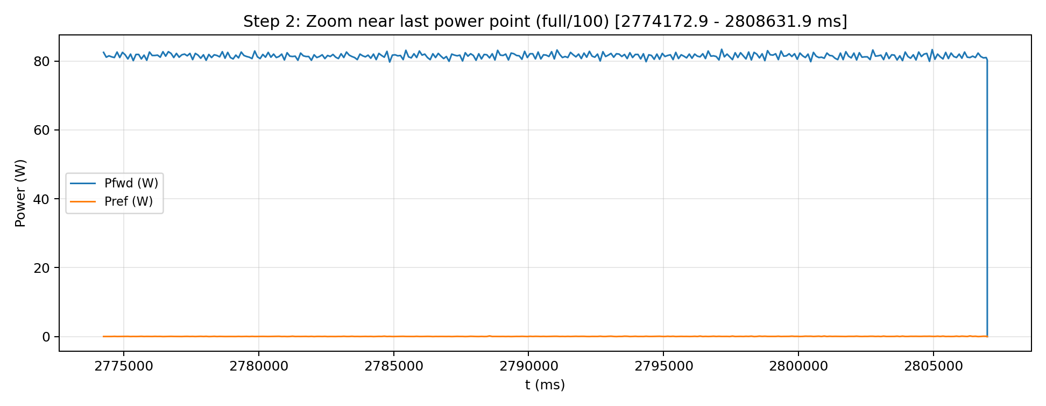
Figure 2. Active-area power plot (idle removed).

Step 3 — Customize time range analysis (1000.0–2000.0 s)
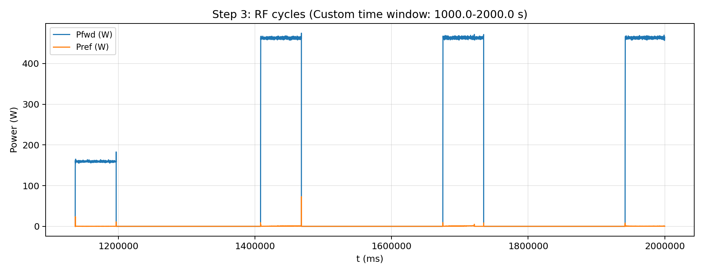
Figure 3. User assigned time range RF cycles.
Step 3 cycle metrics (base on RF on/off signal):
Cycle | Start row() | SetPt (W) | Pfwd steady (W) | Pfwd peak (W) | Overshoot (W) | Overshoot (%) | Rise to 95% (ms) | RF ON (ms) | Idle before (ms) | Mode / Freq / Duty
1 | 30 |  | 7.0 | 14.3 | 7.3 | 104.29 | 1.200 | 2.000 | N/A | Pulse, F=1.002kHz, D=18.6%
2 | 51 |  | 74.4 | 102.7 | 28.3 | 38.01 | 2.000 | 5.800 | 2.200 | Pulse, F=1.002kHz, D=19.2%
3 | 227 |  | 159.2 | 183.0 | 23.8 | 14.96 | 0.000 | 59752.000 | 29.400 | Pulse, F=1.002kHz, D=19.2%
4 | 1015 |  | 70.5 | 73.3 | 2.8 | 3.92 | 6.200 | 7.000 | 207510.600 | Pulse, F=1.002kHz, D=18.9%
5 | 1102 |  | 144.3 | 155.1 | 10.8 | 7.51 | 8.800 | 20.800 | 10.400 | Pulse, F=1.002kHz, D=19.2%
6 | 1277 |  | 159.4 | 185.0 | 25.6 | 16.07 | 0.000 | 59632.600 | 119.000 | Pulse, F=1.002kHz, D=19.2%
7 | 1968 |  | 11.9 | 20.7 | 8.8 | 73.87 | 7.200 | 9.200 | 207219.400 | Pulse, F=1.002kHz, D=9.7%
8 | 2034 |  | 89.0 | 137.1 | 48.1 | 54.12 | 21.000 | 53.000 | 5.000 | Pulse, F=1.002kHz, D=19.2%
9 | 2253 |  | 156.1 | 158.7 | 2.6 | 1.65 | 64.200 | 143.800 | 22.000 | Pulse, F=1.002kHz, D=19.2%
10 | 2284 |  | 159.4 | 182.8 | 23.4 | 14.67 | 0.000 | 59698.600 | 50.400 | Pulse, F=1.002kHz, D=19.2%
11 | 2956 |  | 3.0 | 4.7 | 1.7 | 56.67 | 0.200 | 2.000 | 211321.600 | Pulse, F=1.002kHz, D=8.2%
12 | 2978 |  | 43.2 | 63.1 | 19.9 | 45.99 | 1.800 | 3.600 | 2.400 | Pulse, F=1.002kHz, D=9.1%
13 | 3002 |  | 169.2 | 313.7 | 144.5 | 85.42 | 21.000 | 113.800 | 1.200 | Pulse, F=1.002kHz, D=9.1%
14 | 3859 |  | 426.5 | 474.6 | 48.1 | 11.28 | 0.000 | 3.000 | 59654.000 | CW
15 | 3873 |  | 3.9 | 4.7 | 0.8 | 19.49 | 0.200 | 1.000 | 207021.400 | Pulse, F=1.002kHz, D=8.0%
16 | 3895 |  | 159.3 | 209.3 | 50.0 | 31.36 | 21.800 | 56.600 | 3.400 | Pulse, F=1.002kHz, D=9.1%
17 | 4140 |  | 339.9 | 392.1 | 52.2 | 15.37 | 87.200 | 106.000 | 2.200 | Pulse, F=1.002kHz, D=9.2%
18 | 4790 |  | 2.8 | 4.6 | 1.8 | 62.70 | 0.200 | 2.000 | 266626.600 | Pulse, F=1.002kHz, D=8.0%
19 | 4806 |  | 29.4 | 48.9 | 19.5 | 66.61 | 2.000 | 3.800 | 1.200 | Pulse, F=1.002kHz, D=9.1%
20 | 4841 |  | 147.6 | 161.7 | 14.1 | 9.55 | 9.000 | 20.800 | 3.200 | Pulse, F=1.002kHz, D=9.1%
21 | 5665 |  | 62.7 | 76.8 | 14.1 | 22.54 | 20.200 | 90.200 | 271188.800 | Pulse, F=0.100kHz, D=49.9%
22 | 6531 |  | 0.0 | 0.0 | 0.0 |  |  | 0.000 | 266801.000 | Pulse, F=0.100kHz, D=84.9%
23 | 6582 |  | 76.9 | 83.4 | 6.5 | 8.48 | 140.200 | 59960.400 | 10.200 | Pulse, F=0.100kHz, D=49.9%
24 | 7397 |  | 80.3 | 80.3 | 0.0 | 0.00 | 0.200 | 10.000 | 207210.400 | Pulse, F=0.100kHz, D=4.2%
Detected RF cycles: 13. The plot shows user assigned time range.

Step 4 — Forward Power vs Setpoint (Tykon only)
Quantum: no setpoint, skip Step 4

Step 5 — Reflected Power (Pref high)
Rule: Pref > 1.00% of Pfwd after masking the first 3.0 ms.
Flagged cycles: 13
Cycle | Start row() | First bad row() | Worst row() | Worst Pref (W) | Worst Pref/Pfwd (%)
1 | 36 | 51 | 226 | 25.11 | 15.83
2 | 1021 | 1036 | 1206 | 25.28 | 16.30
3 | 1974 | 1977 | 1977 | 4.15 | 86.46
4 | 1984 | 2009 | 2260 | 23.79 | 15.10
5 | 2957 | 2961 | 2961 | 4.09 | 87.02
6 | 2967 | 2982 | 3866 | 72.88 | 40.94
7 | 3874 | 3878 | 3878 | 4.05 | 86.17
8 | 3884 | 3898 | 4014 | 9.21 | 5.98
9 | 4791 | 4795 | 4795 | 3.87 | 84.13
10 | 4801 | 4821 | 4921 | 8.01 | 5.43
11 | 5666 | 5681 | 5681 | 36.09 | 75.50
12 | 6532 | 6546 | 6546 | 3.40 | 75.56
13 | 7398 | 7413 | 7413 | 57.99 | 72.22
Note: table capped at 200 rows.

Pulse Mode Range Alarms
Pulse-mode rows: 8118
Alarms: 2931
Row() | Type | Value | Unit
29 | PulseFreqOutOfRange | 0.000 | kHz
1014 | PulseFreqOutOfRange | 0.000 | kHz
1967 | PulseFreqOutOfRange | 0.000 | kHz
1968 | PulseFreqOutOfRange | 0.000 | kHz
1969 | PulseFreqOutOfRange | 0.000 | kHz
1970 | PulseFreqOutOfRange | 0.000 | kHz
1971 | PulseFreqOutOfRange | 0.000 | kHz
1972 | PulseFreqOutOfRange | 0.000 | kHz
1973 | PulseFreqOutOfRange | 0.000 | kHz
1974 | PulseFreqOutOfRange | 0.000 | kHz
1975 | PulseFreqOutOfRange | 0.000 | kHz
1976 | PulseFreqOutOfRange | 0.000 | kHz
1977 | PulseFreqOutOfRange | 0.000 | kHz
2955 | PulseFreqOutOfRange | 0.000 | kHz
3872 | PulseFreqOutOfRange | 0.000 | kHz
4789 | PulseFreqOutOfRange | 0.000 | kHz
5664 | PulseFreqOutOfRange | 0.000 | kHz
6530 | PulseFreqOutOfRange | 0.000 | kHz
7396 | PulseFreqOutOfRange | 0.000 | kHz
29 | DutyOutOfRange | 0.000 | %
30 | DutyOutOfRange | 100.000 | %
31 | DutyOutOfRange | 0.200 | %
32 | DutyOutOfRange | 0.200 | %
33 | DutyOutOfRange | 0.200 | %
34 | DutyOutOfRange | 0.200 | %
35 | DutyOutOfRange | 0.200 | %
41 | DutyOutOfRange | 0.800 | %
42 | DutyOutOfRange | 0.800 | %
43 | DutyOutOfRange | 0.800 | %
44 | DutyOutOfRange | 0.800 | %
45 | DutyOutOfRange | 0.800 | %
1014 | DutyOutOfRange | 0.000 | %
1016 | DutyOutOfRange | 0.000 | %
1017 | DutyOutOfRange | 0.000 | %
1018 | DutyOutOfRange | 0.000 | %
1019 | DutyOutOfRange | 0.000 | %
1020 | DutyOutOfRange | 0.000 | %
1026 | DutyOutOfRange | 0.000 | %
1027 | DutyOutOfRange | 0.000 | %
1028 | DutyOutOfRange | 0.000 | %
1029 | DutyOutOfRange | 0.000 | %
1030 | DutyOutOfRange | 0.000 | %
1967 | DutyOutOfRange | 0.000 | %
1968 | DutyOutOfRange | 0.000 | %
1969 | DutyOutOfRange | 0.000 | %
1970 | DutyOutOfRange | 0.000 | %
1971 | DutyOutOfRange | 0.000 | %
1972 | DutyOutOfRange | 0.000 | %
1973 | DutyOutOfRange | 0.000 | %
1974 | DutyOutOfRange | 0.000 | %
1975 | DutyOutOfRange | 0.000 | %
1976 | DutyOutOfRange | 0.000 | %
1977 | DutyOutOfRange | 0.000 | %
1978 | DutyOutOfRange | 0.300 | %
1979 | DutyOutOfRange | 0.200 | %
1980 | DutyOutOfRange | 0.200 | %
1981 | DutyOutOfRange | 0.200 | %
1982 | DutyOutOfRange | 0.200 | %
1983 | DutyOutOfRange | 0.200 | %
1984 | DutyOutOfRange | 0.600 | %
1985 | DutyOutOfRange | 0.600 | %
1986 | DutyOutOfRange | 0.600 | %
1987 | DutyOutOfRange | 0.600 | %
1988 | DutyOutOfRange | 0.600 | %
2955 | DutyOutOfRange | 0.000 | %
2957 | DutyOutOfRange | 8.200 | %
2958 | DutyOutOfRange | 8.200 | %
2959 | DutyOutOfRange | 8.200 | %
2960 | DutyOutOfRange | 8.200 | %
2961 | DutyOutOfRange | 8.200 | %
2962 | DutyOutOfRange | 0.600 | %
2963 | DutyOutOfRange | 0.600 | %
2964 | DutyOutOfRange | 0.600 | %
2965 | DutyOutOfRange | 0.600 | %
2966 | DutyOutOfRange | 0.600 | %
2967 | DutyOutOfRange | 8.800 | %
2968 | DutyOutOfRange | 8.800 | %
2969 | DutyOutOfRange | 8.800 | %
2970 | DutyOutOfRange | 8.800 | %
2971 | DutyOutOfRange | 8.800 | %
2972 | DutyOutOfRange | 9.100 | %
2973 | DutyOutOfRange | 9.100 | %
2974 | DutyOutOfRange | 9.100 | %
2975 | DutyOutOfRange | 9.100 | %
2976 | DutyOutOfRange | 9.100 | %
2977 | DutyOutOfRange | 8.800 | %
2978 | DutyOutOfRange | 8.800 | %
2979 | DutyOutOfRange | 8.800 | %
2980 | DutyOutOfRange | 8.800 | %
2981 | DutyOutOfRange | 8.800 | %
2982 | DutyOutOfRange | 9.100 | %
2983 | DutyOutOfRange | 9.100 | %
2984 | DutyOutOfRange | 9.100 | %
2985 | DutyOutOfRange | 9.100 | %
2986 | DutyOutOfRange | 9.100 | %
2987 | DutyOutOfRange | 9.300 | %
2988 | DutyOutOfRange | 9.300 | %
2989 | DutyOutOfRange | 9.300 | %
2990 | DutyOutOfRange | 9.300 | %
2991 | DutyOutOfRange | 9.300 | %
2992 | DutyOutOfRange | 9.100 | %
2993 | DutyOutOfRange | 9.100 | %
2994 | DutyOutOfRange | 9.100 | %
2995 | DutyOutOfRange | 9.100 | %
2996 | DutyOutOfRange | 9.100 | %
2997 | DutyOutOfRange | 9.300 | %
2998 | DutyOutOfRange | 9.300 | %
2999 | DutyOutOfRange | 9.300 | %
3000 | DutyOutOfRange | 9.300 | %
3001 | DutyOutOfRange | 9.300 | %
3002 | DutyOutOfRange | 9.100 | %
3003 | DutyOutOfRange | 9.100 | %
3004 | DutyOutOfRange | 9.100 | %
3005 | DutyOutOfRange | 9.100 | %
3006 | DutyOutOfRange | 9.100 | %
3007 | DutyOutOfRange | 9.100 | %
3008 | DutyOutOfRange | 9.100 | %
3009 | DutyOutOfRange | 9.100 | %
3010 | DutyOutOfRange | 9.100 | %
3011 | DutyOutOfRange | 9.100 | %
3012 | DutyOutOfRange | 9.100 | %
3013 | DutyOutOfRange | 9.100 | %
3014 | DutyOutOfRange | 9.100 | %
3015 | DutyOutOfRange | 9.100 | %
3016 | DutyOutOfRange | 9.100 | %
3017 | DutyOutOfRange | 9.100 | %
3018 | DutyOutOfRange | 9.100 | %
3019 | DutyOutOfRange | 9.100 | %
3020 | DutyOutOfRange | 9.100 | %
3021 | DutyOutOfRange | 9.100 | %
3022 | DutyOutOfRange | 9.300 | %
3023 | DutyOutOfRange | 9.300 | %
3024 | DutyOutOfRange | 9.300 | %
3025 | DutyOutOfRange | 9.300 | %
3026 | DutyOutOfRange | 9.300 | %
3027 | DutyOutOfRange | 9.100 | %
3028 | DutyOutOfRange | 9.100 | %
3029 | DutyOutOfRange | 9.100 | %
3030 | DutyOutOfRange | 9.100 | %
3031 | DutyOutOfRange | 9.100 | %
3032 | DutyOutOfRange | 9.300 | %
3033 | DutyOutOfRange | 9.300 | %
3034 | DutyOutOfRange | 9.300 | %
3035 | DutyOutOfRange | 9.300 | %
3036 | DutyOutOfRange | 9.300 | %
3037 | DutyOutOfRange | 9.100 | %
3038 | DutyOutOfRange | 9.100 | %
3039 | DutyOutOfRange | 9.100 | %
3040 | DutyOutOfRange | 9.100 | %
3041 | DutyOutOfRange | 9.100 | %
3042 | DutyOutOfRange | 9.300 | %
3043 | DutyOutOfRange | 9.300 | %
3044 | DutyOutOfRange | 9.300 | %
3045 | DutyOutOfRange | 9.300 | %
3046 | DutyOutOfRange | 9.300 | %
3047 | DutyOutOfRange | 9.100 | %
3048 | DutyOutOfRange | 9.100 | %
3049 | DutyOutOfRange | 9.100 | %
3050 | DutyOutOfRange | 9.100 | %
3051 | DutyOutOfRange | 9.100 | %
3052 | DutyOutOfRange | 9.100 | %
3053 | DutyOutOfRange | 9.100 | %
3054 | DutyOutOfRange | 9.100 | %
3055 | DutyOutOfRange | 9.100 | %
3056 | DutyOutOfRange | 9.100 | %
3057 | DutyOutOfRange | 9.100 | %
3058 | DutyOutOfRange | 9.100 | %
3059 | DutyOutOfRange | 9.100 | %
3060 | DutyOutOfRange | 9.100 | %
3061 | DutyOutOfRange | 9.100 | %
3062 | DutyOutOfRange | 9.100 | %
3063 | DutyOutOfRange | 9.100 | %
3064 | DutyOutOfRange | 9.100 | %
3065 | DutyOutOfRange | 9.100 | %
3066 | DutyOutOfRange | 9.100 | %
3067 | DutyOutOfRange | 9.300 | %
3068 | DutyOutOfRange | 9.300 | %
3069 | DutyOutOfRange | 9.300 | %
3070 | DutyOutOfRange | 9.300 | %
3071 | DutyOutOfRange | 9.300 | %
3072 | DutyOutOfRange | 9.100 | %
3073 | DutyOutOfRange | 9.100 | %
3074 | DutyOutOfRange | 9.100 | %
3075 | DutyOutOfRange | 9.100 | %
3076 | DutyOutOfRange | 9.100 | %
3077 | DutyOutOfRange | 9.300 | %
3078 | DutyOutOfRange | 9.300 | %
3079 | DutyOutOfRange | 9.300 | %
3080 | DutyOutOfRange | 9.300 | %
3081 | DutyOutOfRange | 9.300 | %
3082 | DutyOutOfRange | 9.100 | %
3083 | DutyOutOfRange | 9.100 | %
3084 | DutyOutOfRange | 9.100 | %
3085 | DutyOutOfRange | 9.100 | %
3086 | DutyOutOfRange | 9.100 | %
3087 | DutyOutOfRange | 9.300 | %
3088 | DutyOutOfRange | 9.300 | %
3089 | DutyOutOfRange | 9.300 | %
3090 | DutyOutOfRange | 9.300 | %
3091 | DutyOutOfRange | 9.300 | %
Note: table capped at 200 rows.

